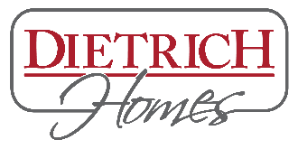DIETRICH HOMES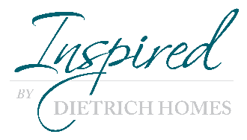
POSITION DESCRIPTION

POSITION TITLE: Accountant/Office Manager
ACCOUNTABLE: President, Vice President

Dietrich Homes, Inc. is a design, build firm specializing in custom home builds and renovations. Quality and attention to detail are cornerstones of all our projects and a main focus of all team members.

PRIMARY OBJECTIVE OF POSITION
The position is responsible for direct oversight of the day to day accounting operations combined with daily office management tasks. The position will work closely with our Vice President/Business Manager, Design team and outside subcontractors and suppliers to complete all necessary accounting tasks.

ESSENTIAL FUNCTIONS AND RESPONSIBILITIES:
- Day to day accounting operations
- Payroll – biweekly schedule
- Manage cafeteria plan inclusive of Health Insurance, AFLAC and 401(k)
- Manage accounts receivable, accounts payable and collections
- Job costing and change orders for all projects.
- Processing customer payments and bank deposits
- Monthly bank reconciliation for all cash accounts
- Quarterly Payroll Tax Returns & Use Tax Returns
- Annual 1099 and W2 Returns
- Prepare monthly company financials and assist third party accounting company with year-end tax returns
- Prepare quarterly inventory and financial reports for outside financial institution
- Maintain and orderly accounting filing system
- Maintain confidential HR records
- Work directly with outside IT company on all in house IT needs and support
- Office duties inclusive of answering phone, mail, ordering of supplies and maintenance of office equipment
- Assist with marketing efforts with third party marketing company
QUALIFICATIONS
Education and Experience:
- Associates Degree in Accounting and 3-5 years of Accounting Experience
- Proficiency in Sage Contractor 100 (preferred) or QuickBooks
- Proficiency in MS Office Suite
- Previous experience in Payroll and employee benefit plans

Other skills and abilities:
- Excellent written and verbal communication skills
- Superior organizational skills
- Detail oriented and self-motivated
- Ability to build efficient working relationships with project teams, department staff, subcontractors and clients

PAY & BENEFITS
- Compensation dependent on experience
- Paid Time Off
- Paid Holidays
- 401k Match
- Cafeteria Plan

11/2021

